## Install WebSphere

Install IBM Installation Manager Install Kit for all x86_64 Windows versions supported by version 1.8.9.1 fix.[agent.installer.win32.win32.x86_64_1.8.9001.20180709_1302.zip (166.24 MB)](https://ak-delivery04-mul.dhe.ibm.com/sdfdl/v2/sar/CM/RA/07pti/0/Xa.2/Xb.jusyLTSp44S02UcEFKoopssAGebqfJikHttuq_-E9pFkQXuMwKQMLJCtBno/Xc.CM/RA/07pti/0/agent.installer.win32.win32.x86_64_1.8.9001.20180709_1302.zip/Xd./Xf.LPR.D1VC/Xg.9903253/Xi.habanero/XY.habanero/XZ.tonONkfAkVqWjXd4pN7h_scy1Fo/agent.installer.win32.win32.x86_64_1.8.9001.20180709_1302.zip)

Extract it & Install it. 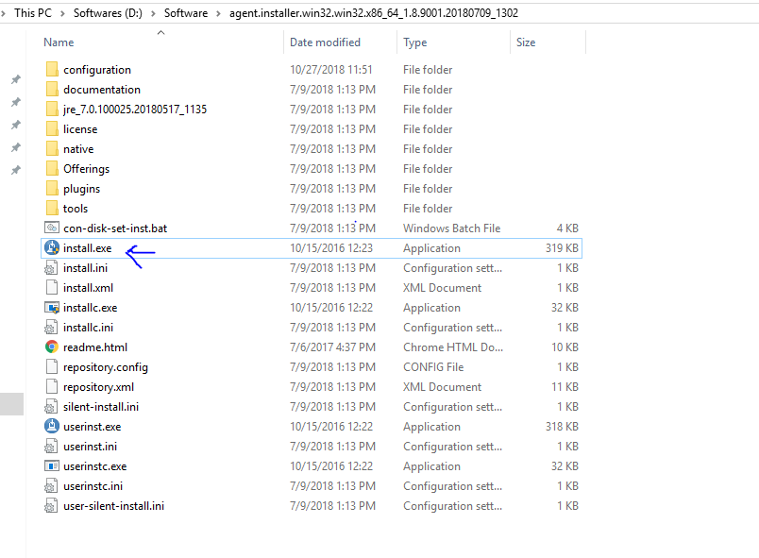

After Installation Manager is installed, configure the IBM-hosted repository.

1. In Installation Manager, go to **File > Preferences**.
2. In the Repositories panel, click the **Add Repository** button. Enter the repository URL for the version of WebSphere Application Server that you want to install:
   * Version 9.0: https://www.ibm.com/software/repositorymanager/V9WASILAN
   * Version 8.5: https://www.ibm.com/software/repositorymanager/V85WASDeveloperILAN

If prompted, authenticate with the IBM-hosted repository using your My IBMid credentials.  
When Installation Manager connects to the repository URL, the connection status icon turns green.

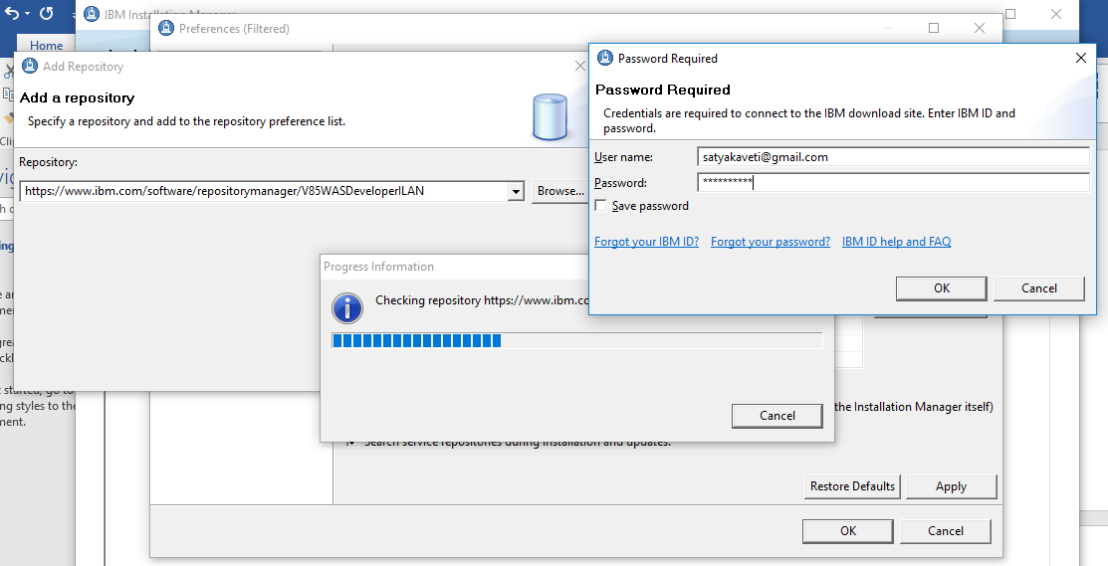

Installation will take time , after install open eclipse to configure WebSphere in eclipse.

Eclipse > Help > Market Place > Search for ‘websphere’ developer tools, based on your eclipse version install them.

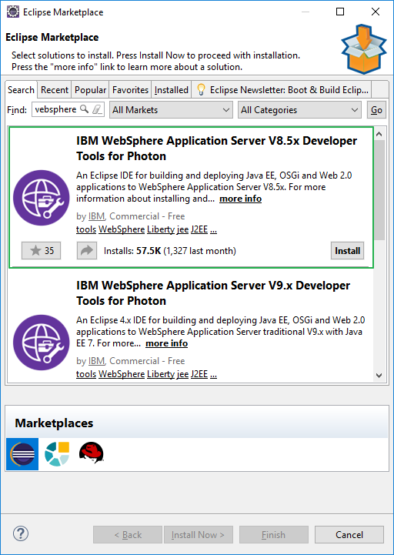

## Create WebSphere Profile

After install Open Eclipse > Windows menu > Preferences > Server > WebSphere Application Server> Run Profile Management Tool.

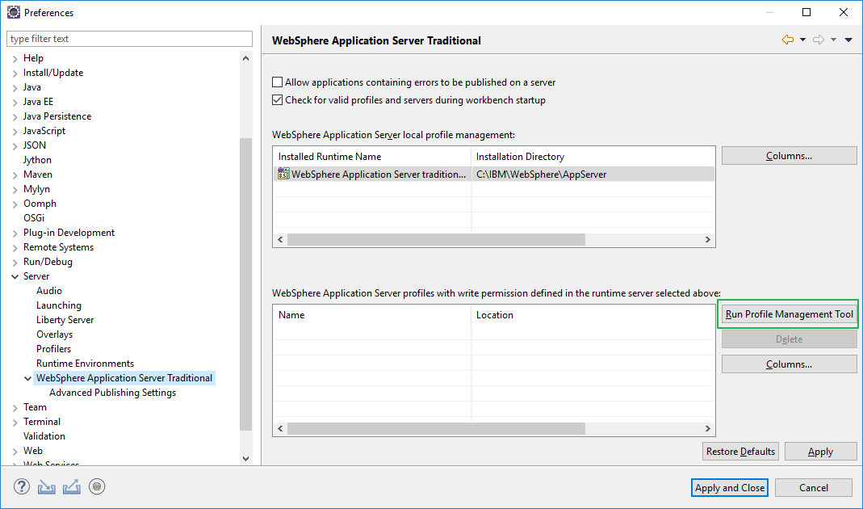

Select Profile Management Tool > Create >Application Server > Advanced Profile, follow steps

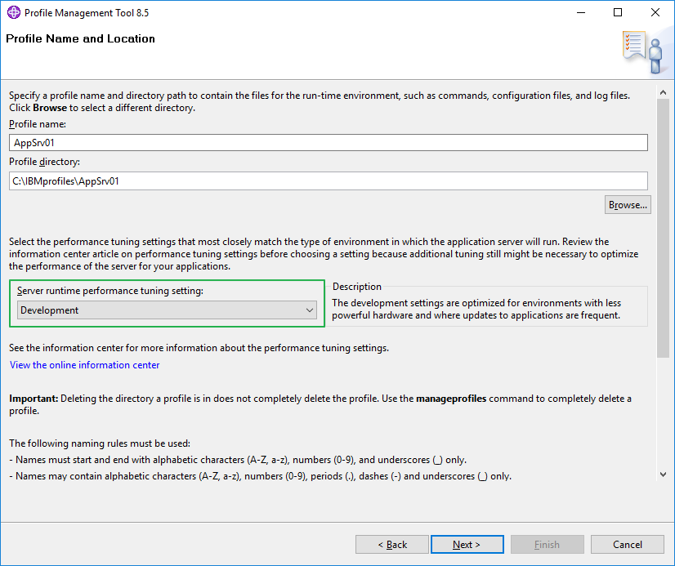

Next, uncheck: Enable Admin login things for dev environment & Run as Windows Service, create!!

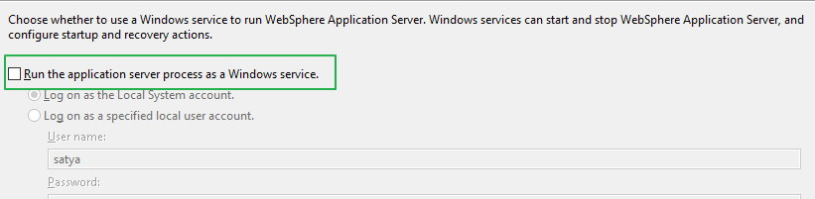

## Adding Server to Eclipse

Open Eclipse > Servers Tab > New > Server & Follow Below Screens

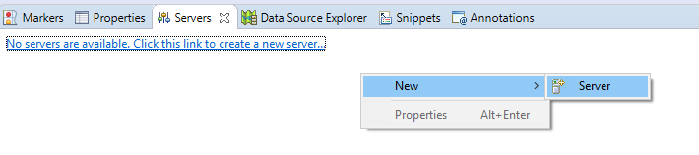

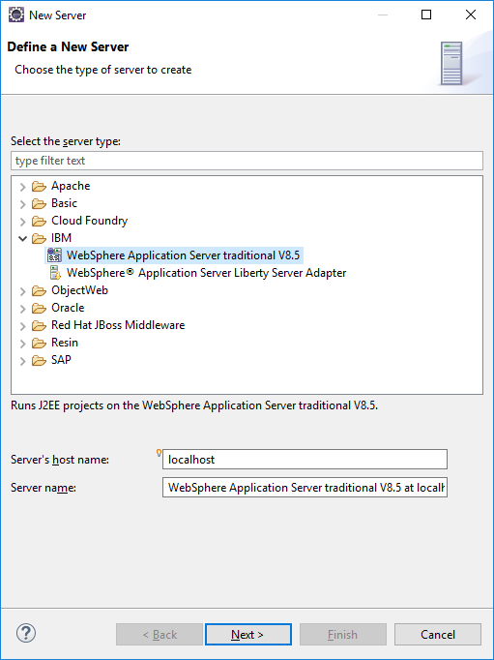

Then Seelect AppServer location, C:\IBM\WebSphere\AppServer

